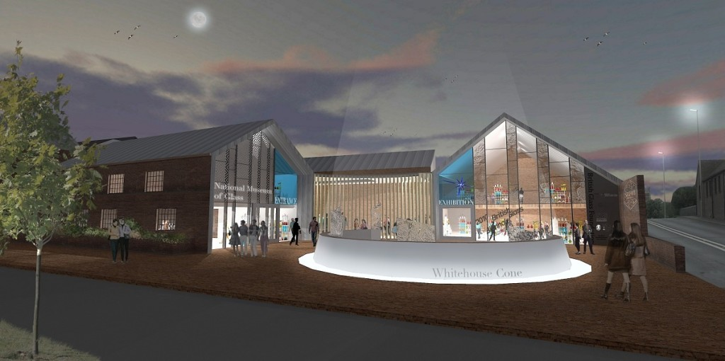Volunteer Application Form
Thank you for your interest in volunteering for Stourbridge Glass Museum
We need you to tell us about yourself so we can see how you would fit within our organisation and help us find the right role for you.
All the information you give us will be held securely on the Volunteer database and is strictly confidential. There is a full statement about volunteer data collection and a declaration for you to sign at the end of this form.
Please complete all parts of the form.
Personal Details:
Title: |  |  |  |  |  |  |  |  |  | Home Tel:
Surname: |  |  |  |  |  |  |  |  |  | Work/Daytime Tel:
First name(s): in full |  |  |  |  |  |  |  |  |  | Mobile Tel:
Home Address:
Email Address:
About Volunteering
What volunteering roles are you interested in?
Tour Guiding |  |  |  |  |  |  | Collections Care
Front of House |  |  |  |  |  |  | Other roles within the Museum
Have you volunteered for us before? |  |  |  |  |  |  |  |  |  |  |  |  |  |  |  |  |  | Yes |  | No
Have you volunteered for another organisation before? |  |  |  |  |  |  |  |  |  |  |  |  |  |  |  |  |  | Yes |  | No
What has inspired you to volunteer?

How did you hear about volunteering? |  |  | Leaflet |  |  |  |  | From TV/radio |  |  |  | Local paper |  |  |  |  | Word of mouth
 |  |  | Our website |  |  |  |  | Another website |  |  |  | Other (please tell us)
Please give brief details of your SKILLS AND EXPERIENCE
This can include employment background, formal, informal and work-based training.
If you wish to include a CV separately, please attach one to the form.
Please give brief details of your BACKGROUND AND INTERESTS
This can include hobbies, interests and previous volunteering experience.
Availability – Please tick the relevant boxes to give us general idea of your availability
 | Mon |  |  |  |  | Tues |  |  | Wed |  | Thurs |  |  | Fri |  | Sat |  |  | Sun
Morning
Afternoon
Evening
Referees
We want to provide volunteers, staff and our visitors with a safe, reliable and enjoyable experience. So we ask volunteers for a reference to make sure that we know what to expect and that you are serious about committing time to us.

Please provide details of two referees to support your application. Referees should be people such as employers, ex-employers, tutors, people you have volunteered for in the past or someone with whom you have a professional relationship. One of the referees can be a friend, someone you have worked with or a fellow volunteer. We do not accept relatives as referees.
 |  |  |  |  | Referee 1 |  |  |  |  |  |  |  | Referee 2
Name
Relationship to you
Address
Postcode
Telephone
Email Address
Volunteers Data Collection Information
The information you provide will be used to process your application and help us with induction if you join our volunteer team. Application forms sent to be us via email will be held on a secure server and paper forms will be kept in a locked filing cabinet. If you no longer wish to volunteer with us then all personal information will be deleted.
I understand the above data collection information
Signed:

Please return this form to: mmadigan@stourbridgeglassmuseum.org.uk
Alternatively post to Volunteer Coordinator, Stourbridge Glass Museum,
High Street,
Wordsley,
Stourbridge
DY8 4FB

